Chapter 4 Test Review

- Solve the system of equations:
3x – 8y = 4
y = 6x + 7

a. (4/3, 1)
b. (-4/3, -1)
c. (1, 4/3)
d. (-1, -4/3)

- Solve the system of equations:
3x + 2y = 22
-x + 4y = 2

a. (-6, 2)
b. (-6, -2)
c. (6, -2)
d. (6, 2)

- Ms. Wiggins solved the system of equations below:
3x + 2y = 4
3x + 6y = -24

She found the solution to be the point where x= -6 and y= -7.

Solve the system of equations, and show all the steps necessary to explain whether Ms. Wiggins is correct. If her solution is not right, find the solution to the system of equations.

- What is the y coordinate of the solution for the system of equations below?
7x – 4y = -12
x – 2y = 4

a. -4
b. 4
c. 1/4
d. -1/4

- Mayke buys three belts and four hats for $80.00 at a store. His friend Casey buys one belt and two hats at the same store for $30.00. If each belt costs the same and each hat costs the same, which of the following shows the system of equations that can be used to find the cost of a belt and a hat and includes the solution?
- 4x + 3y = 80 B. 3x + 4y = 80
x + 2y = 30 x + 2y = 30
Solution: $20 per belt Solution: $20 per belt
$5 per hat $5 per hat

- 3x + 4y = 80 D. 3x + 4y = 80
2x + y = 30 x + 2y = 30

Solution: $20 per belt Solution: $5 per belt
$5 per hat $20 per hat

- Eight shrimps and five crab Rangoon at A-1 Wok cost $10. 95. Six shrimps and five crab Rangoon at China Express cost $8.95. Which option shows the best method for calculating the amount that each restaurant is charging for each shrimp and each Crab Rangoon?
- -8s = $19.90
- 14s = $19.90
- 8s + 5c = $10.95 and 6s + 5c = $8.95
- 8 + 5(s + c) = $10.95 and 6 + 5(s + c) = $8.95

- South City market charges $5.75 for a large turkey sandwich and two large lemonades. For a large turkey sandwich and a large lemonade, they charge $5.00. How much are the turkey sandwiches?
- $4.25
- $4.25 with 2 lemonades and $5.00 with 1 lemonade
- $5.00
- $5.25

- Mr. Howard bought seven adult passes and three child passes at sky zone for $192.00. Mr. Rodgers bought five adults passes and four child passes at sky zones for $165.00.
- Write a system of linear equations that can be used to determine the price of an adult pass and a child pass.
- Using the system from part A, algebraically determine whether it is possible to buy four child passes with $60. Justify answer.

- Choose the system of inequalities represented by the following graph.

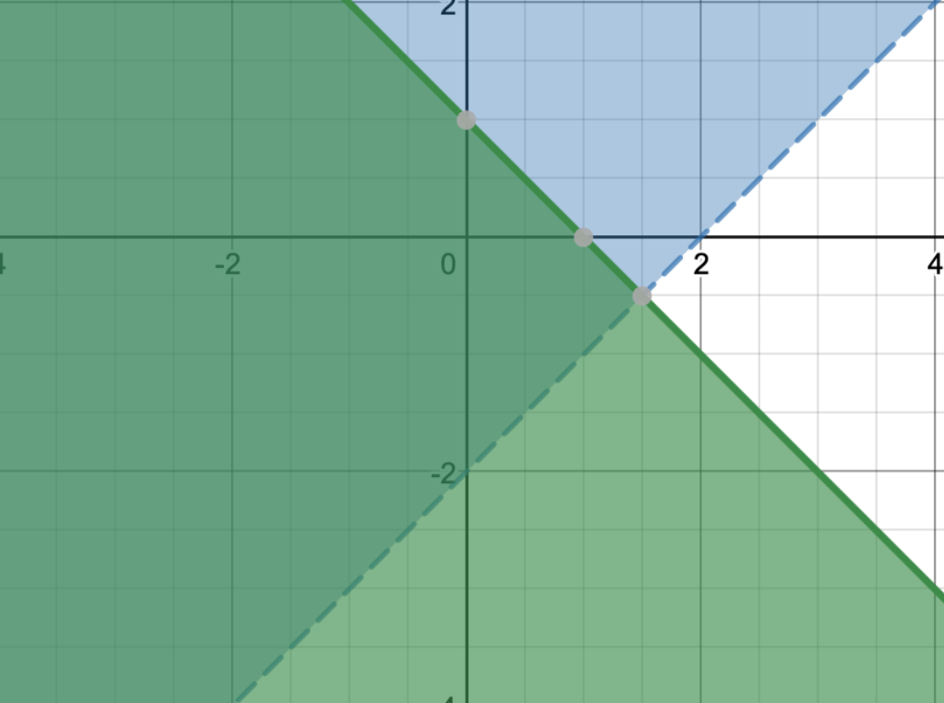

- $y < x – 2$
$$y > -x + 1$$

- $y > x – 2$
$y≤-x+1$ -

- $y ≥ -x-2$
$y≤x-1$

- $y<x-2$
$y≤ -x+1$
- Which graph correctly represents the solution to the following system of inequalities?
$$y ≥3x+2$$

$$y ≤x-2$$

- 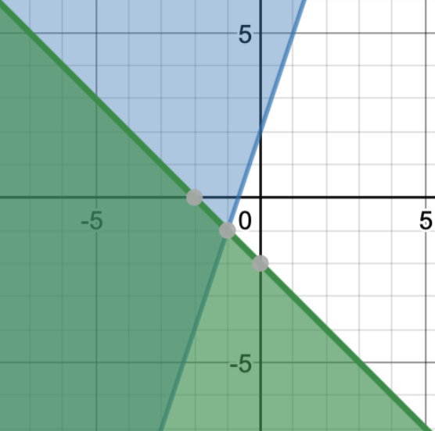

- 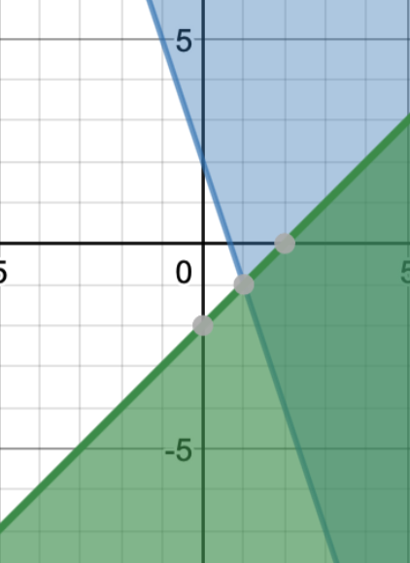

- 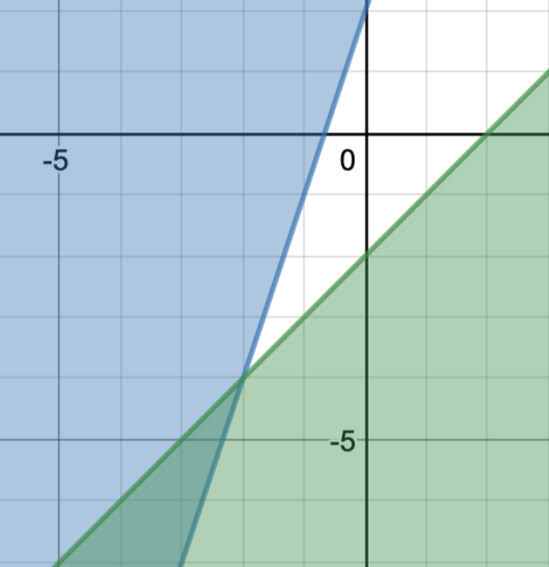

- 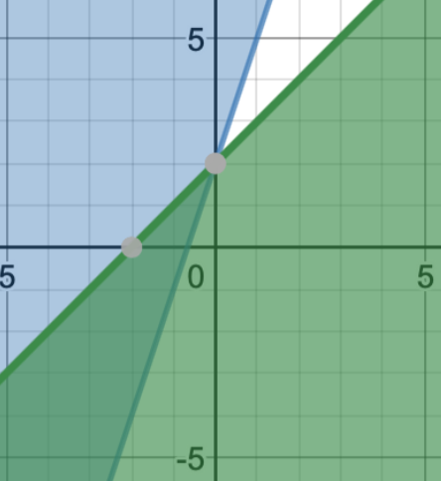

- Graph the system of inequalities below. Complete on separate graphing sheet.

$$y <2x+1$$

$$y ≤-x-4$$

